Blazing Trails Childcare

Inclusion Policy

Our Statement of Anti-discrimination,

Anti-bias & Cultural Sensitivity

We foster an understanding of diversity among people, expecting and modeling unconditional respect for self and others. We enjoy celebrating and exploring our community’s rich cultural diversity.

All children and their families are accepted according to our policies without regard to race, color, religion or belief structure, creed, ancestry, gender or gender identity, sexual orientation, national origin or the presence of any sensory, mental or physical challenges. We have no religious affiliation.

Our mission is to…

…provide staff and families a safe, diverse childcare environment dedicated to respectful communication, problem solving, creative learning and the freedom to play!

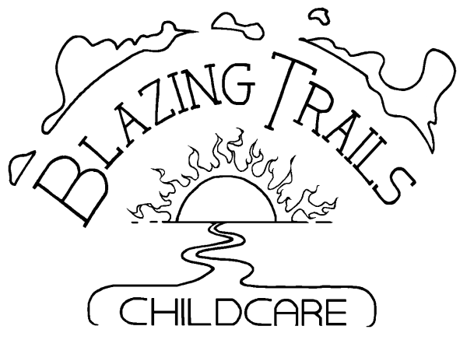

at
Pathfinder K - 8
School

2024 – 2025 School Year

1901 SW. Genesee Street
Seattle, WA 98106

Rita Garton – Director
BT Office: 206-937-5160
Rita’s Cell: 206-459-4976

Check us out at …
www.blazingtrails.org

About our program
Blazing Trails, located at Pathfinder K - 8 in West Seattle, is a non-profit before and after school childcare program for school-age children ages five through twelve.

Open registration for the 2024-25 school year begins April 5, 2024. Registration paperwork may be found online and in house 1 week prior, however forms will not be accepted until April 5th. Paperwork may be returned in person, by email or post.

We fill up quickly, so register early!

Children are organized into Communities of Respect (CoRs) Raccoons are Kindergarten & 1st grade, Badgers are 2nd grade and above, along with any student not yet ready for/interested in the Lynx CoR. Lynx are 5th through 7th graders who, by displaying readiness and interest, have been invited to join. Projects are CoR based. Activities including field trips can be mixed-CoRs, depending on the curriculum. Check with Blazing Trails’ office for program details.

BT Philosophy and Vision
Our vision: “Children are empowered to discover their worth.”

We are dedicated to supporting families in our community as we help each child develop good communication skills and celebrate his or her own uniqueness. We maintain an environment that encourages intellectual, physical and social growth with respect for others and the natural environment. People relate to each other peacefully and we joyfully appreciate our rich diversity.

Staff training is a crucial component to accomplishing our goals. We support our staff, both professionally and personally, through respect for each other’s personal differences and unique teaching styles. We provide opportunities for shared leadership, professional growth and development and an environment that encourages mutual support and care.
General Information

- We are open from 6:30 to 8:45 AM before school and from 3:25 to 6:00 PM after school. Times may be slightly different for bus riders.
- We are open all school days (except BT training days) and only certain vacation days. See the B.T. Calendar for more information.
- Our goal is to inspire positive self-esteem, respect for self and others, a sense of responsibility for one’s own behavior and a respectful caring for our environment.
- Blazing Trails maintains, on average, at least an 11 to 1 student/teacher ratio, varying with different activity types. For example, more kids per teacher with gym/playground activities and less with directed projects. No group is ever larger than 15:1.
- We have use of Pathfinder’s playground, grassy fields, cafeteria, gym facilities and covered play-court.
- We provide healthy snacks.
- Our curriculum is child-centered, culturally relevant and developmentally appropriate. Activities might include, but are not limited to:
Movement games, sports and outdoor play, science discoveries, cooking, story reading and telling, community service, beading, sewing and other arts & crafts, table games, field trips during vacations, theme and club related projects of all kinds (e.g. Pokémon, puppetry, team challenges, etc.) and individual study
- “Independent Study” is available M through Th afternoon to help 2nd – 6th graders with their homework. Students enjoy herbal tea while focusing in a quiet, supportive environment. You may request your child have “mandatory” attendance on these days. We can also accommodate those wanting more time.
- Blazing Trails is a non-profit organization with its own governing board.
- We offer “drop-ins” when space is available.
- Blazing Trails accepts DSHS and City subsidies and has some scholarships available (limited) or work trade at the Director’s discretion.

Blazing Trails Childcare

Blazing Trails Childcare is Pathfinder K – 8’s onsite childcare program for school age children ages 5 to 12. We are open from 6:30 AM to 6:00 PM, excluding Pathfinder school hours of operation. Please ask us in the B.T. office or check our website for more information.

Blazing Trails Tuition & Fees

We have a $50.00 non-refundable registration fee per child required to hold your spot. Although we are located at Pathfinder K-8, children from other schools may attend if they have transportation (See reg. form, BT Handbook or our website for more info on busing). We enroll on a “first come, first served” basis.

Amounts listed are based on a 4 week month. Months will be billed according to the number of weeks in the month. Some months may have 5 weeks and others only 3, so amounts will adjust accordingly. Please refer to the BT Calendar for an exact number of billing weeks for each month.

*NOTE: Every Wednesday will have a 75 minute early dismissal – adding $8.00 per Wednesday to the basic tuition. Choose from the options below depending on whether or not you need a Wednesday afternoon. Combine any morning/afternoon schedule as fits your needs. Just add both numbers for your usual monthly tuition.

 | 5 days | 4 days | 3 days | 2 days | 1 day
Before | $269 | $244 | $198 | $145 | $78
After w/o Wednesday | n/a | $371 | $324 | $245 | $129
After w/ Wednesday | $440 | $407 | $371 | $281 | $164

Extra Fees may be added based on your schedule, changes to that schedule and additional circumstances. Some extra fees are below.
- Early Dismissal fee – (not Wed.) $7 for 1 hr.
- Late Pick-up - $5 for each 5 minutes starting at 6:05 PM
- Kid Search fee - $5 per occurrence
- Late Payment fee - $10 per occurrence
- Early AM/Late PM bus - $5 discount per day
- Late AM/Early PM - $5 added per day

Drop-in Options

You may register your child for using drop-ins as space is available at the rates below. There is a $30.00 reg. fee if you wish to use only drop-ins in lieu of a regular schedule.

“All Day” Day  6:30 – 6:00 | 6:30 – 8:35 (9:00) AM | 3:25 – 6:00 PM | Early Dis. Wednesday
$72.00 | $19.50 | $32.25 | $41.00

